**DHAKA UNIVERSITY OF ENGINEERING & TECHNOLOGY, GAZIPUR**



Department of Computer Science and Engineering

Course No.: **CSE-2112**

Course Title: **Object Oriented Programming Language Sessional**

*Lab No:* **07**

*Lab Name:* Virtual Base Class, Virtual Function

Experiment Date: **25-05-2021** Submission Date: **28-05-2021**

***Submitted By-***

Name: **Mehedi Hasan Shuvo**

Student Id.: 194016

Year: 2nd

Semester: 1st

Session: 2019 - 2020

***Submitted To:***

**Mr.Md. Omor Farque**

**Associative Professor, Department of CSE**

**Mss. Sabah Binte Noor**

**Associative Professor, Department of CSE**

**Problems No:** 01

**Problem Title:**

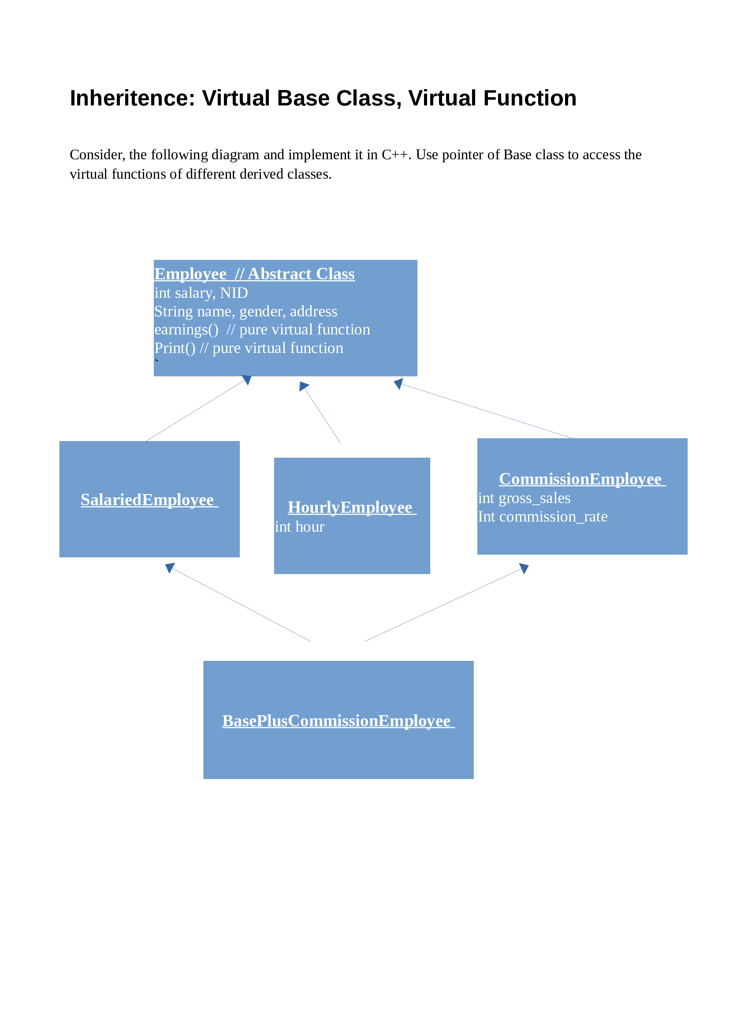

**Solution:**

|  |
| --- |
| #include <bits/stdc++.h>  using namespace std;  class Employee  {      int salary;      int nid;      string name;      string gender;      string address;  public:      Employee(int salary, int nid, string name, string gender, string address)      {          this->salary = salary;          this->nid = nid;          this->name = name;          this->gender = gender;          this->address = address;      };      int getSalary() { return salary; }      int getNid() { return nid; }      string getName() { return name; }      string getGender() { return gender; }      string getAddress() { return address; }      // create a virtual function      virtual int print() = 0;      virtual int earning() = 0;  };  class SalariedEmployee : virtual public Employee  // inherit Employee class as virtual base class  {  public:      SalariedEmployee(int salary, int nid, string name, string gender,  string address) : Employee(salary, nid, name, gender, address) {}    int print()      {          cout << "Name: " << getName() << endl;          cout << "Gender: " << getGender() << endl;          cout << "Nid: " << getNid() << endl;          cout << "Salary: " << getSalary() << endl;          cout << "Address: " << getAddress() << endl;          return 0;      }      int earning()      {          cout << "Salary Is : " << getSalary() << endl               << endl;          return 1;      }  };  class HourlyEmployee : virtual public Employee  // inherit Employee class as virtual base class  {      int hour;  public:      HourlyEmployee(int salary, int hour, int nid, string name, string gender, string address) :   Employee(salary, nid, name, gender, address)      {          this->hour = hour;      }      int print()      {          cout << "Name: " << getName() << endl;          cout << "Gender: " << getGender() << endl;          cout << "Nid: " << getNid() << endl;          cout << "Salary: " << getSalary() * hour << endl;          cout << "Address: " << getAddress() << endl;          return 0;      }      int earning()      {          cout << "Salary Is : " << getSalary() * hour << endl               << endl;          return 1;      }  };  class CommisionEmployee : virtual public Employee  // inherit Employee class as virtual base class  {      int grossSales;      int commisionRate;  public:      CommisionEmployee(int salary, int grossSales, int commisionRate, int nid, string name,  string gender, string address) : Employee(salary, nid, name, gender, address)      {          this->grossSales = grossSales;          this->commisionRate = commisionRate;      }      int getgrossSales() { return grossSales; }      int getcommisionRate() { return commisionRate; }      int print()      {          cout << "Name: " << getName() << endl;          cout << "Gender: " << getGender() << endl;          cout << "Nid: " << getNid() << endl;          cout << "Commision: " << (grossSales * commisionRate) << endl;          cout << "Address: " << getAddress() << endl;          return 0;      }      int earning()      {          cout << "Earning Commision Is : " << grossSales * commisionRate << endl               << endl;          return 1;      }  };  class BasPlusCommissionEmployee : public CommisionEmployee, public SalariedEmployee  {  public:      BasPlusCommissionEmployee(int salary, int grossSales, int commisionRate, int nid,  string name, string gender, string address) :    CommisionEmployee(salary, grossSales, commisionRate, nid, name, gender, address),     Employee(salary, nid, name, gender, address),     SalariedEmployee(salary, nid, name, gender, address) {}      int print()      {          cout << "Name: " << getName() << endl;          cout << "Gender: " << getGender() << endl;          cout << "Nid: " << getNid() << endl;          cout << "Salary: " << getSalary() + (getgrossSales() * getcommisionRate()) << endl;          cout << "Address: " << getAddress() << endl;          return 0;      }      int earning()      {          cout << "Salary Is : " << getSalary() + (getgrossSales() * getcommisionRate()) << endl               << endl;          return 1;      }  };  int main()  {      SalariedEmployee salariedEmployee(200, 12322, "Mehedi Hasan Shuvo", "Male", "Kalkini, Madaripur");      HourlyEmployee hourlyEmployee(200, 2, 23232, "Md. Mamun", "Male", "Borguna,Barisal");      CommisionEmployee commisionEmployee(200, 10, 5, 54543333, "Md Nazmul Islam", "Male", "Pabna,Rajshahi");      BasPlusCommissionEmployee basePlusCommisionEmployee(200, 10, 5, 54543333, "Md. Yaunus", "Male", "Chottogram");    cout << "======== ****** Salaried Based Employee Information ***** =======" << endl << endl;      Employee *e;      e = &salariedEmployee;      e->earning();      e->print();      cout << endl<< "======== ****** Hourly Based Employee Information ***** =======" << endl << endl;      e = &hourlyEmployee;      e->earning();      e->print();      cout << endl<< "======== ****** Commision Based Employee Information ***** =======" << endl << endl;      e = &commisionEmployee;      e->earning();      e->print();      cout << endl<< "======== ****** Base Plus Commision Based Employee Information ***** =======" << endl<< endl;      e = &basePlusCommisionEmployee;      e->earning();      e->print();      cout << endl;      return 0;  } |
|  |

**Output:**



**Thanks**